7.56: a) The energy stored may be found directly from
b) Denote the upward distance from point 2 by h. The kinetic energy at point 2 and at the height h are both zero, so the energy found in part (a) is equal to the negative of the work done by gravity and friction, so 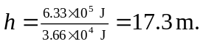 c) The net work done on the elevator between the highest point of the rebound and the point where it next reaches the spring is 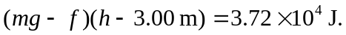 Note that on the way down, friction does negative work. The speed of the elevator is then 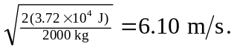 d) When the elevator next comes to rest, the total work done by the spring, friction, and gravity must be the negative of the kinetic energy 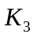 found in part (c), or

(In this calculation, the value of k was recalculated to obtain better precision.) This is a quadratic in 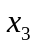, the positive solution to which is
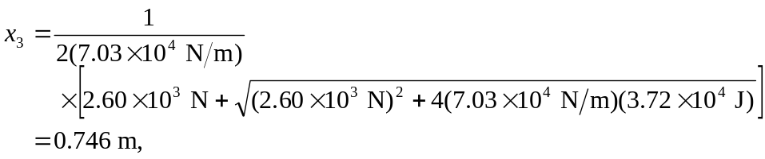

corresponding to a force of 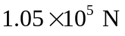 and a stored energy of 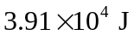. It should be noted that different ways of rounding the numbers in the intermediate calculations may give different answers.

